Course Report Online SEEMET 2020

SUMMARY

SEEMET (South-East Europe Meteorological Training) community together with EUMETSAT and technical support from EUMETCAL delivered an online training course for the benefit of the South-East European forecaster community. SEEMET initiative started in 2016. In previous 4 years the course was held in form of face-to-face workshops at the premises of SEEMET members (Ljubljana, Slovenia in 2016, Bar, Montenegro in 2017, Primosten, Croatia in 2018 and Sarajevo, Bosnia and Herzegovina in 2019), alternating advanced courses with specific topics (floods and flash floods, convection) and the basic satellite data application courses.
Due to covid-19 pandemic, the face-to-face workshops were cancelled, therefore the 2020 course was conducted exclusively online, with facilitators adjusting the delivery method and the assessment methods and tools to continue to engage with participants and deliver effective training.
The preparation phase of the course took place in EUMETCAL Moodle platform from 5 to 16 October 2020. During the preparation phase, the participants could read the material in the Moodle platform and prepare cases for the discussion during the workshop. Padlet tool was used for the personal presentation of the participants and also for preparing the cases for the workshop.
The online workshop took place from 19 to 21 October 2020. It consisted of presentations in the morning and practical exercises in the afternoon.

The SEEMET 2020 course was an advanced training course with a topic: Forecasting of development and life cycle of the extratropical cyclones.

The objective of the course was to improve the skills of operational meteorologists in the interpretation of satellite images and products in combination with other relevant data, leading to improved competencies in weather forecasting with regards to cyclones. With this, the course aimed to contribute to improving the capabilities of the NHMSs in South Eastern Europe in providing weather and warning services to national stakeholders and communities.

The specific learning objectives were:
- Identifying different types of cyclones
- Forecasting cyclone development, life-cycle, track and related weather, incorporating appropriate NWP products into forecasting chain
- Choose the right satellite and radar products to identify cyclone-related features
- Assess the impact of the cyclone activity
- Warn on the threats related to cyclones and communicate the forecast and warning to the public

The course was run in English language.

The target audience were operational forecasters from SEEMET countries.

Altogether 24 participants from 12 SEEMET countries applied for the course. Out of this, 24 participants 4 never accessed the Moodle page of the course and 14 participants successfully finished the course.

INSTRUCTORS

Tanja Renko, DHMZ, Croatia
Andreas Wirth, EUMeTrain
Matjaz Licer, National Institute of Biology, Slovenia
Rebecca Hemingway, ECMWF
Mark Rodwell, ECMWF
Ivan Smiljanic, EUMETSAT
Natasa Strelec Mahovic, EUMETSAT

EUMETCAL supported the course.

EUMETSAT Training Zone (Moodle environment) was used for applications whereas EUMETCAL Moodle environment was used for delivering course material. The evaluation report for the course can be found at the end of this report in appendices.

What was successful?

This was the first SEEMET course delivered entirely online.
Padlet tool was used for the first time in SEEMET with a success. In practical part of the course E-port tool of EUMeTrain was used as well as a Simulator, both with success.
The ratio of theoretical sessions and practical work was very good and well accepted. The interactivity with the participants and among participants was satisfactory, especially during practical sessions group work (the participants were split into groups for some of the exercises).

What can we improve?

Participants were lacking personal contact and developing relationships, the forum was not used (it was available, but not used). It should be considered to include other platforms to enable personal contact and to enable some kind of “coffe-break” interactions, if the course is delivered fully online.

It is clear that some participants would still prefer face-to-face workshops: “Just to say lectures were interesting, but I believe it would be more useful in person, than via application like Zoom or other apps.”

There is obviously a need for continuing training: “Perhaps organizing the short courses (lecture+exercise) on various topics (satellite data, synoptic features on satellite images, etc.) especially when MTG will be operational in national services.”
A comment about how EUMETSAT could support their learning was: “By organizing more frequently online training courses, which are easier to attend to”.

Instructors feedback

Instructors were generally very satisfied with the course, especially with the fact that even practical exercises went smoothly, despite the online setup.
Ivan Smiljanic: “… we had a very 'good feeling' about the structure of the course and (for the first time virtual) interaction with students.”
Rebecca Hemingway, ECMWF: “It was a new experience for everyone but a very positive one. Personally, I think the course went very well, the combination of presentations and practicals was good and re-enforced the learning. I really like the simulator exercise, I've never seen anything like it before! My only comment would be on presentation timings, maybe in the future (should the course be virtual again) the morning session should be expanded to 2.5 hours to allow enough time for the presentations and questions / discussion.”
Myself and ECMWF would really like to continue to be involved with events like this…”

General impression is that the course was successful and very well accepted. The objectives were met, despite the new, fully online environment. However, this type of forecaster courses would still be more useful online, since it would enable making personal contact between the participants, which can be very valuable in their everyday operational work.

Evaluation report

14 participants filled the evaluation report. Here is the analysis:

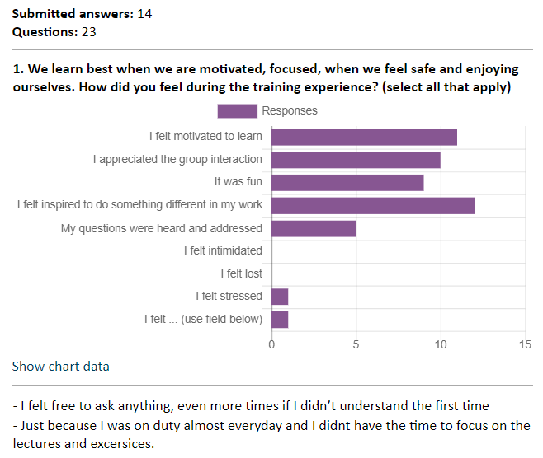
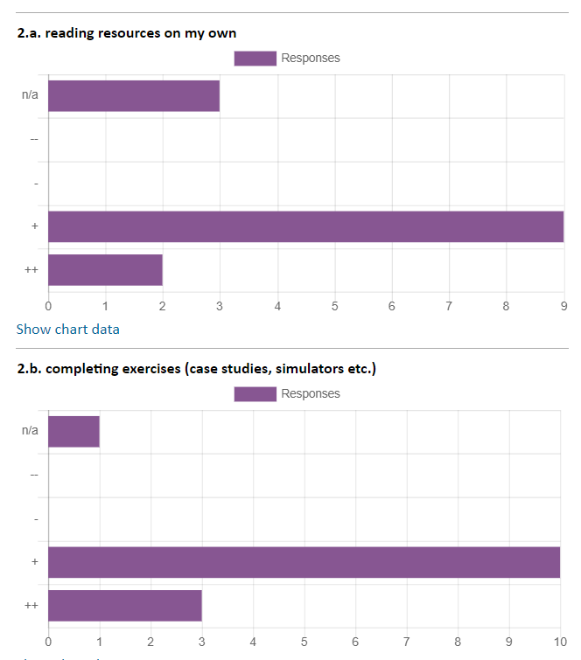

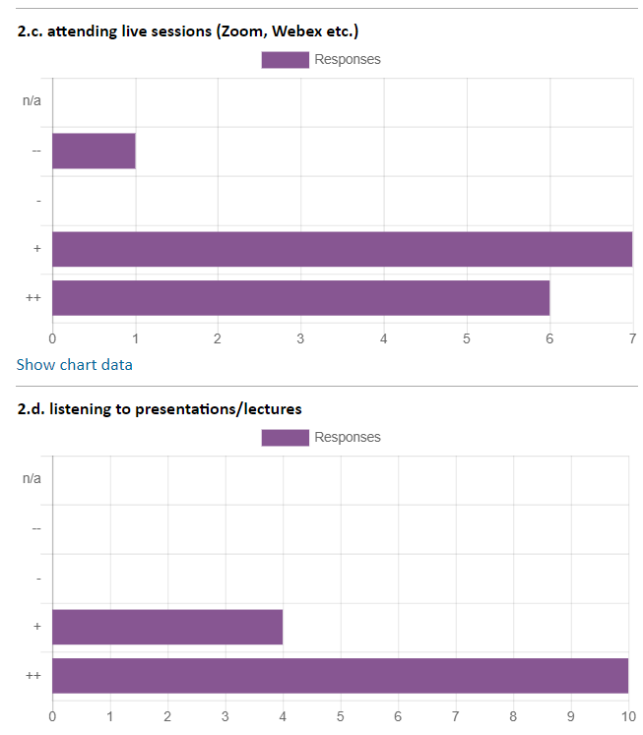
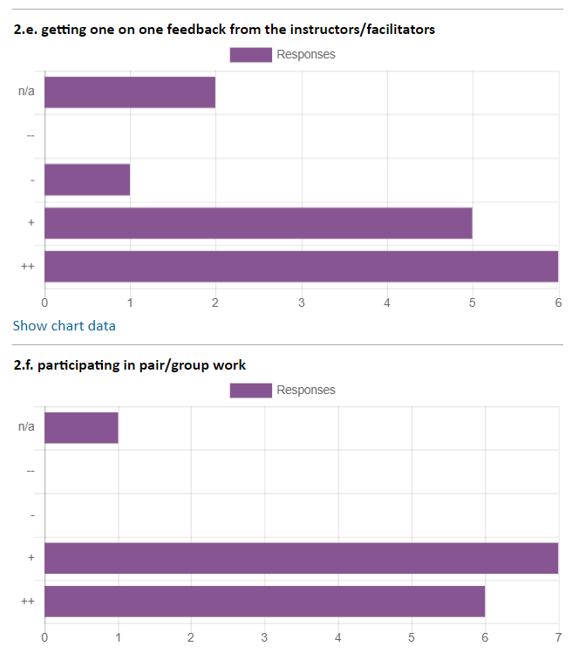
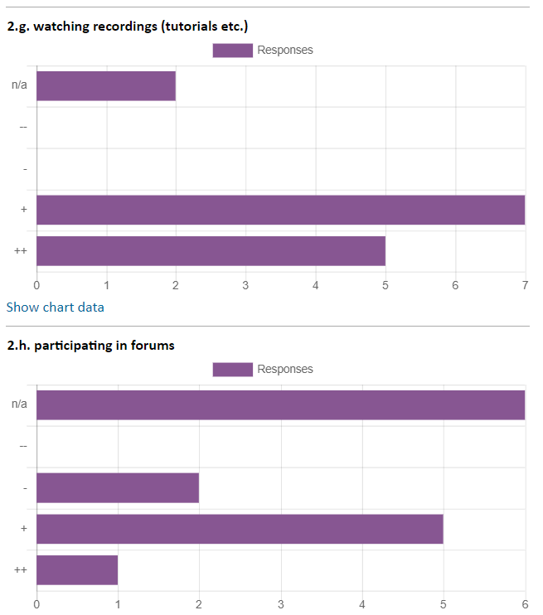
3. From what you’ve learned during the training, what do you plan to apply in your work and how?
Through satellite data I will analyze cyclone to find out is it a Norwegian or Shapiro-Keyser type. Also I will try to investigate more about Adriatic Sea features and how it reacts on different speeds of sirocco wind in combination with astronomical tides.
Shapiro-Keyser model will help me understand the synoptic situation better when starting the shift. Also, start thinking more on terms of impact and likelihood when issuing warnings. I am not sure if I will have access to the eumet-train map viewer, but, If I will have access to that tool in the future, I will use it to analyze specific cases and discuss them with my colleagues.
The information about different satellite products and how to "read" them.
using cross sections
cross section analysis, cyclone tracking
Mostly things related with satellite images, because rest of resources that has been used by lecturers is not common for us.
To analyse cyclones and fronts better in the future.
Trainers, working in group, participants
I dont know yet
Definitely, when analyzing frontal systems and issuing warnings.
applied satellite products in the everyday forecast
I will apply everything I have learned new
I'll use more often the Airmass RGB and the vertical crossections for fields, and mix the modells standard data (geopot., isotacha, etc.) with satellite images. At first I'll have to create some macros in our weather visualization system.

4. What questions you still have unanswered on the topic of the training, if any?
I didn't have any.
Is there some different weather types in warm core of Shapiro-Keyser cyclone in comparison with Norwegian cyclone?
not exist
No questions.
Just to say lectures where interesting, but I believe it would be more useful in person, than via application like Zoom or other apps.
no
none

5. We hope that every session was useful and contributed towards the course goals. If you have feedback on a specific session that we should improve, let us know.
I think every session is adequately prepared and useful
Yes, it was useful.
It was useful all, less with Adriatic sea, because our country doesn't have border with sea, but not means it was not interesting.
During the simulation exercise, I think it would be better to determine the region / country for which a forecast should be made (I think this is the first task). Furthermore, the wind field in the simulator was difficult to see, it was not clearly visible, but the colored barbs helped.
All the sessions were useful and contributed towards the course goals
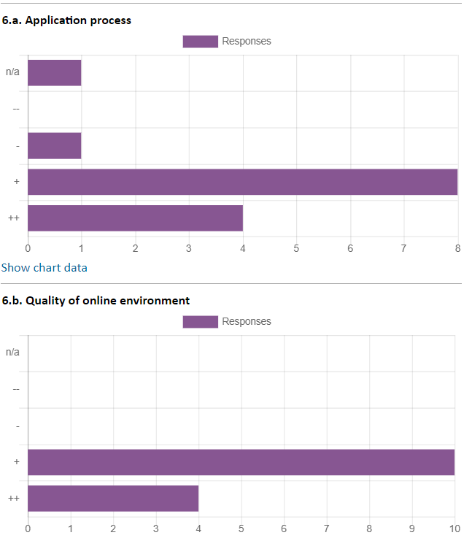

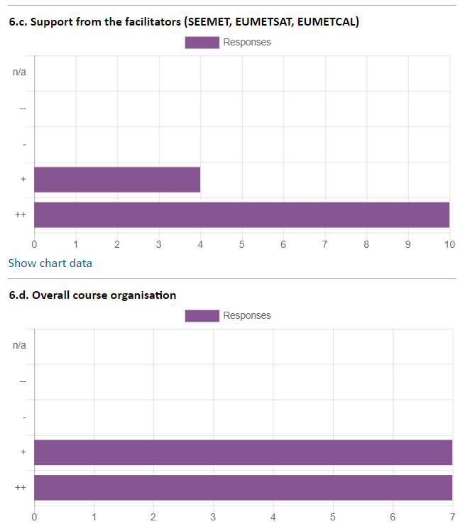
7. If you experience organisational issues, please describe them here.
none
The course was well organized, no complaints!
Nothing to add, everything was fine.

8. If you encountered technical issues during the course, please detail here. Let us know if you were able to resolve them and how.
No problems!
Some cross section through e port during the online exercise did not work properly, but our facilitators provided them
No technical issues.
There was a technical issue while doing the cross sections in ePort for the online exercise (long delays)

9. Anything else we should do differently in the next course to improve?
none
I have no suggestions yet. The amount of content in this course is just right for following lectures and exercises without any problems and for application in the work immediately after the end of the course.
At the moment everything was fine.

10. Finally, a training course alone is rarely enough to support the complex challenges we face at work. How else can EUMETSAT support your learning?
By organizing more frequently online training courses, which are easier to attend to
The most challenging thing is that not many people understands English
That's enough .
Perhaps organizing the short courses (lecture+exercise) on various topics (satellite data, synoptic features on satellite images, etc.) especially when MTG will be operational in national services.
With more online courses

