How assessment works in the 2019 WMO/Eumetcal Course for Trainers on Blended Learning

The primary goal for the course is that you take away useful skills and knowledge to apply to your work. This will require more than just visiting the site occasionally and reading the resources and posts in the forums. It also requires that you regularly contribute to activities and complete assignments related to the learning objectives. But the required work is not extensive, and we expect that each of you can complete the course within the expected level effort of 8 hours each week, plus some preparatory work during the Pre-Course phase.

There are two levels of assessment and two ways of indicating your successful completion: Badges and Completion Certificates.
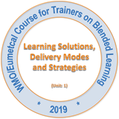
Badges

Badges are awarded for completion of each unit in the course. The units correspond to key learning outcomes related to the WMO Competency Requirements for Education and Training Providers, so badges provide one indication of your developing training competency.

A Badge for a unit is granted once you have completed the activities and viewed the resources required, including the final unit quiz or other assignments. What determines completion for activities can vary.
- For some Discussion Forums, for example, you must make one post, which can be either a reply to someone else or the start of a new discussion.
- Quizzes, on the other hand, require a passing grade of 65%.
- Content resources must simply be read (not applicable to resources in the optional readings lists).
- Other activities might have other requirements for completion, and these will be explained in their instructions.

Completion Certificates

For this offering of the Online Course for trainers only one type of certificate will be granted. This Certificate of Completion requires two conditions to be met:
- You collect the Badges for each unit.
- You submit and receive a Satisfactory grade on the Course Projects.

(See the “Course Projects” at the end for more details on requirements.)

Your badges and how to check your progress

A total of 5 badges can be earned for Unit completion in the Course for Trainers. You can monitor your completion toward Badge achievement by viewing the completion check boxes next to the required activities and resources, including discussion forums.

When completed, you will see a checkmark () on the course page next to that activity or resource.

If you do not see a checkbox next to an activity or resource, this means it is useful but optional, and not required for the badge.

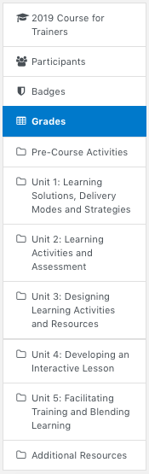
Your grades and how to check them

To receive a Certificate of Completion, you must submit (upload) the graded course projects, which are labeled “Assignment” and available within Units 1, 2, 4, and 5. These mandatory activities are assigned grades of either 0 (Not Satisfactory), 1 (Satisfactory), or 2 (Outstanding). A score of 1 is required for completion.

You can track your grades in the ‘Grades’ area, which can be viewed in the left-hand side of the website. Each mandatory and graded activity will have a separate row in the ‘Grades’ report, thus this is the easiest way to have an overview of your grades. You can also check individual activities to see more details and feedback.

In addition to graded assignments, in the ‘Grades’ report you will also see your ratings received for the course discussion forums, which are described in the next section.

Rating posts in a forum

You will use many forums in this course. They are the main way you will interact with facilitators and the other participants. You should strive to make the majority of your forum posts substantive. While at times it is perfectly good to just tell another participant or facilitator thanks for a good idea or that you agree, many posts should do more. Others want to hear your thoughts! The best posts should contribute to the discussion by sharing your ideas, posing an answer, asking a useful question, or sharing a relevant experience.

The rating feature, available below each post, will enable you to indicate the posts of other participants that you “Like,” as well as those that you feel make especially “Excellent contributions” to the course. No rating is required, but everyone (both participants and facilitators) can rate those posts they especially like. You will see the number of times a post was rated by the number indicated as “Count of ratings” as they accumulate. You can see the particular ratings on the posts also by clicking the number of the Count of ratings.
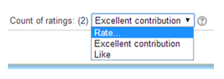

Course Projects

Course Projects are assignments that will be read by a Coach, who will provide you feedback. Coaches will be assigned to each participant by the end of the pre-course. You will know who is your coach not later than when you receive the feedback for your Training Development Plan #1 submission (due 26 April).

There are two Course Projects in this course:
- The Training Development Plan (TDP), which is submitted in several steps during the Pre-Course and Units 1, 2, and 5.
- Developing an interactive lesson, which is an assignment you will work on during Unit 4.
Detailed instructions on how to work on these Course Projects are presented within the course website. The deadlines to submit these projects are highlighted below:

Unit | Course Project | Deadline
Pre-course | TDP Topic | 19 April
Pre-course | TDP #1 | 26 April
Unit 1 | TDP #2 | 5 May
Unit 2 | TDP #3 | 12 May
Unit 4 | Developing an interactive lesson | 26 May
Unit 5 | TDP #4 | 2 June

In order to obtain the Certificate of Completion, participants need to earn all 5 Badges (one for each of the 5 units) and complete the 2 Course Projects.

Finally, all participants are also invited to participate in the Live Webinars, which will be offered in Units 2, 3, and 4. Webinars will be recorded, so watching the recordings will be possible in case you are not available at the date and time of live presentations. While these are not a requirement for course completion, they are valuable opportunities to interact with fellow participants and learn about new topics.

Note that ultimately your competency must be demonstrated on the job. Completion of training is an indication of growing knowledge and skill, but not necessarily improvement in job performance.

